Terraform Challenge – Microservice
Goal of the Exercise
The goal of this exercise is to test your understanding of a Cloud Compute deployment with Terraform.
You are tasked with creating a codebase for a microservice deployment on a cloud environment, using Terraform. Since our focus is not the application itself, the service will be a simple web server that returns a static page.

Requirements
Service Details
- The service will be a simple web server that returns a static page.
- You can useapache2ornginxto serve a simple HTML file.
- The service should becontainerizedand stored in aDocker registry.
- The service should be deployed on asingle VM instanceas a docker container.
- The image should be pulled from the registry specified earlier.
- The service shouldnotbe accessible from the internet but only through aLoad Balancer, except for SSH access from specific IP addresses.
Deliverables
You are to provide the following as part of your solution:
- Dockerfileto build the image.
- Terraform codebaseto deploy the following:
  - Docker registry
  - VPC and all required networking resources
  - EC2 instance
  - Load Balancer
Notes
- Since a CI/CD pipeline is not part of this exercise, we will work around that with the help of Terraform.
- To push the image to the Docker registry,build the image locallybefore running the Terraform code.
- Once the image registry is created, use Terraform topush the local imageto the registry.
- Similarly, use Terraform topull the imagefrom the registry and run it on the VM instance once it is created.
- For SSH access:
  - Use a locally created key.
  - Add it to the cloud provider key storage.
  - Attach it to the instance.
- UseTerraform best practicesfor file structure and code organization.
  - Use variables, locals, modules, etc. when appropriate.
- Include alltfvars, scripts, and other helper files used to deploy the application.
- You may use any cloud provider of your choosing, althoughAWS is preferred.
- Use afree tier accountor atrial accountto deploy the resources.

Challenge Overview

This challenege demonstrates a complete cloud-native microservice deployment on AWS using Terraform for infrastructure and Docker for containerization. The goal was to deploy a simple Nginx web server serving a static HTML page, accessible only through an Application Load Balancer (ALB), not directly from the internet — except for SSH access from a specific IP address.

Step-by-Step Deployment Process

Step 1: Prerequisites
- Terraform installed on local machine
- AWS CLI configured with access credentials (aws configure)
- Docker installed on local machine
- Docker Hub account created (username: javeebms7)
- EC2 Key Pair named 'jenkins' created in AWS Console and .pem file saved locally

Step 2: Build and Push Docker Image
# Navigate to project folder
cd microservice/

# Build the Docker image
docker build -t javeebms7/microservices:v1 .

# Log in to Docker Hub
docker login

# Push image to Docker Hub
docker push javeebms7/microservices:v1

1.1 What Was Built
At a high level, the following infrastructure was created entirely using code (Infrastructure as Code):

Component | Technology Used | Purpose
Web Server | Nginx inside Docker container | Serves the static HTML page
Container Image | Docker + Docker Hub | Packages the application for portability
Virtual Machine | AWS EC2 (t3.micro) | Runs the Docker container
Network | AWS VPC + Subnets + IGW | Isolated private network on AWS
Load Balancer | AWS ALB (Application Load Balancer) | Public entry point for all web traffic
Security | AWS Security Groups | Controls who can access what and on which port
Infrastructure Code | Terraform (.tf files) | Creates/manages all AWS resources automatically

1.2 Architecture Diagram (Text Representation)

Internet (Users)
|
v
[ALB - Port 80] <-- Only this is exposed to the internet
|
v
[EC2 Instance - Public Subnet]
|
v
[Docker Container: Nginx on Port 80]
|
v
[index.html -> Static HTML Page]

SSH Access: Only from IP 103.24.20.203

1.3 Why This Architecture?
The requirement said: 'The service should NOT be accessible from the internet but only through a Load Balancer.
- The Load Balancer sits in front of the EC2 instance. Users hit the ALB, not the EC2 directly.
- The EC2 Security Group only allows port 80 traffic coming from the ALB's Security Group — not from the open internet.
- SSH (port 22) is only open to one specific IP address, not to the whole world.
- Docker containers make the application portable — the same image runs anywhere, on any machine.

2. Project File Structure & Organisation
Terraform best practices recommend splitting code into separate files by purpose. This makes the code easier to read, maintain, and debug. The project follows this structure:

project/
├── main.tf --> All AWS resources (VPC, EC2, ALB, etc.)
├── variables.tf --> Input variable declarations
├── outputs.tf --> Values to display after terraform apply
├── terraform.tfvars --> Actual values for variables (SSH IP, key name)
├── Dockerfile --> Instructions to build the Docker image
└── index.html --> The static web page the container serves

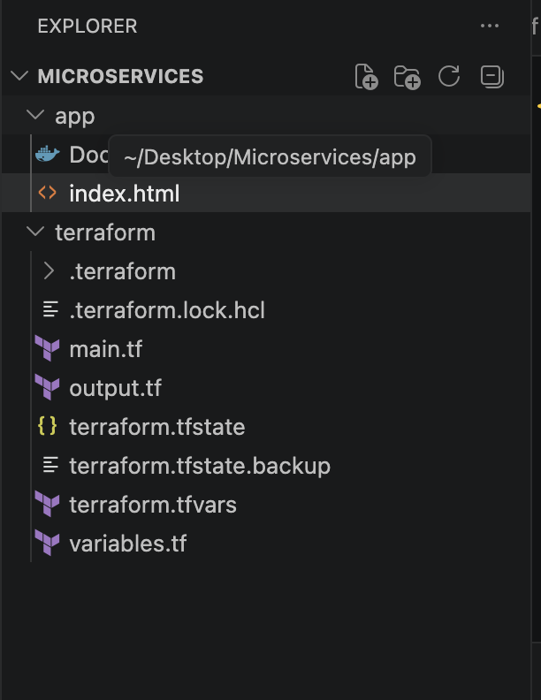

2.1 Why Separate Files?
File | What It Contains | Why Separated
main.tf | All infrastructure resources | Central place for all AWS resource definitions
variables.tf | Variable declarations (type + description) | Makes code reusable — change values without touching logic
terraform.tfvars | Actual values (your IP, key name) | Keep sensitive/environment-specific values separate
outputs.tf | Values printed after deployment | Quick way to get the ALB URL and EC2 IP without logging in to AWS

3. Dockerfile — Building the Container Image

3.1 The Dockerfile
FROM nginx:latest

COPY index.html /usr/share/nginx/html/index.html

EXPOSE 80
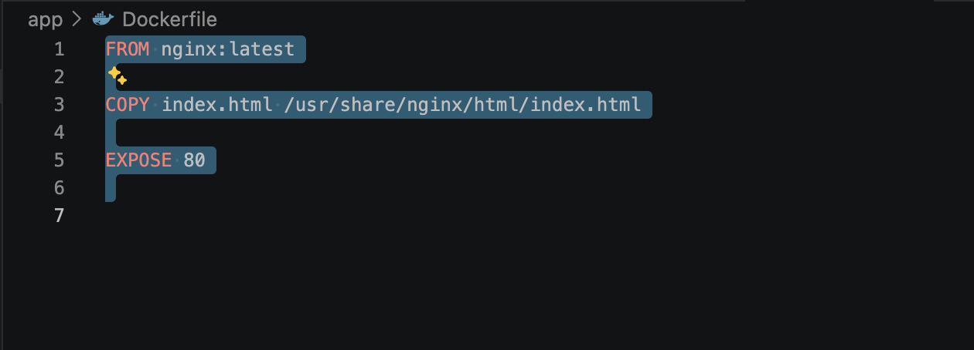

3.2 Line-by-Line Explanation

Line | What It Does | Plain English Explanation
FROM nginx:latest | Sets the base image | Start with an official Nginx web server already installed inside a container. Think of it as renting a pre-built room.
COPY index.html ... | Copies our HTML file into the image | Take our custom HTML file from our computer and put it inside the container at the path where Nginx looks for web pages.
EXPOSE 80 | Documents the port | Tells Docker that this container will listen on port 80 (HTTP). It doesn't open the port itself — just documents the intent.

3.3 The HTML Page (index.html)
The static page is intentionally simple — the exercise is about infrastructure, not web development. The HTML page confirms the deployment worked:
<!DOCTYPE html>
<html>
<head>
<title>Terraform Microservice</title>
</head>
<body>
<h1>Hello from Docker Container!</h1>
<p>Deployed using Terraform on AWS EC2.</p>
</body>
</html>
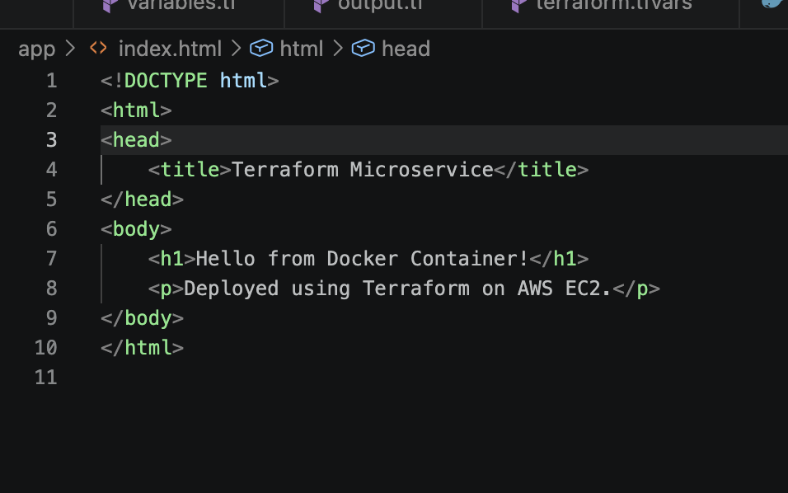

3.4 Building & Pushing the Image to Docker Hub
Since there is no CI/CD pipeline in this exercise, the image was built and pushed manually before running Terraform:

# Step 1: Build the image locally
docker build -t javeebms7/microservices:v1 .

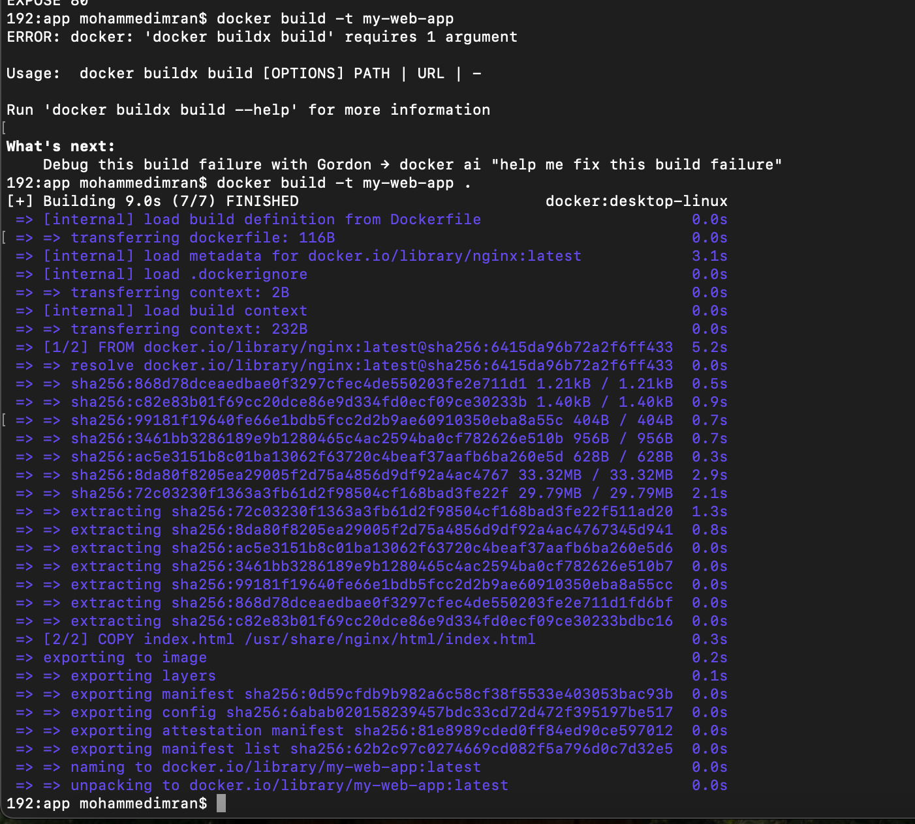

# Step 2: Log in to Docker Hub
docker login

# Step 3: Push the image to Docker Hub
docker push javeebms7/microservices:v1
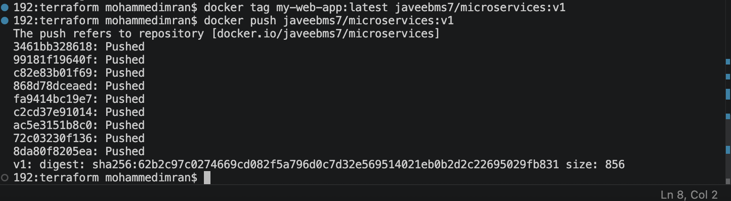
Lets check in our Docker registry
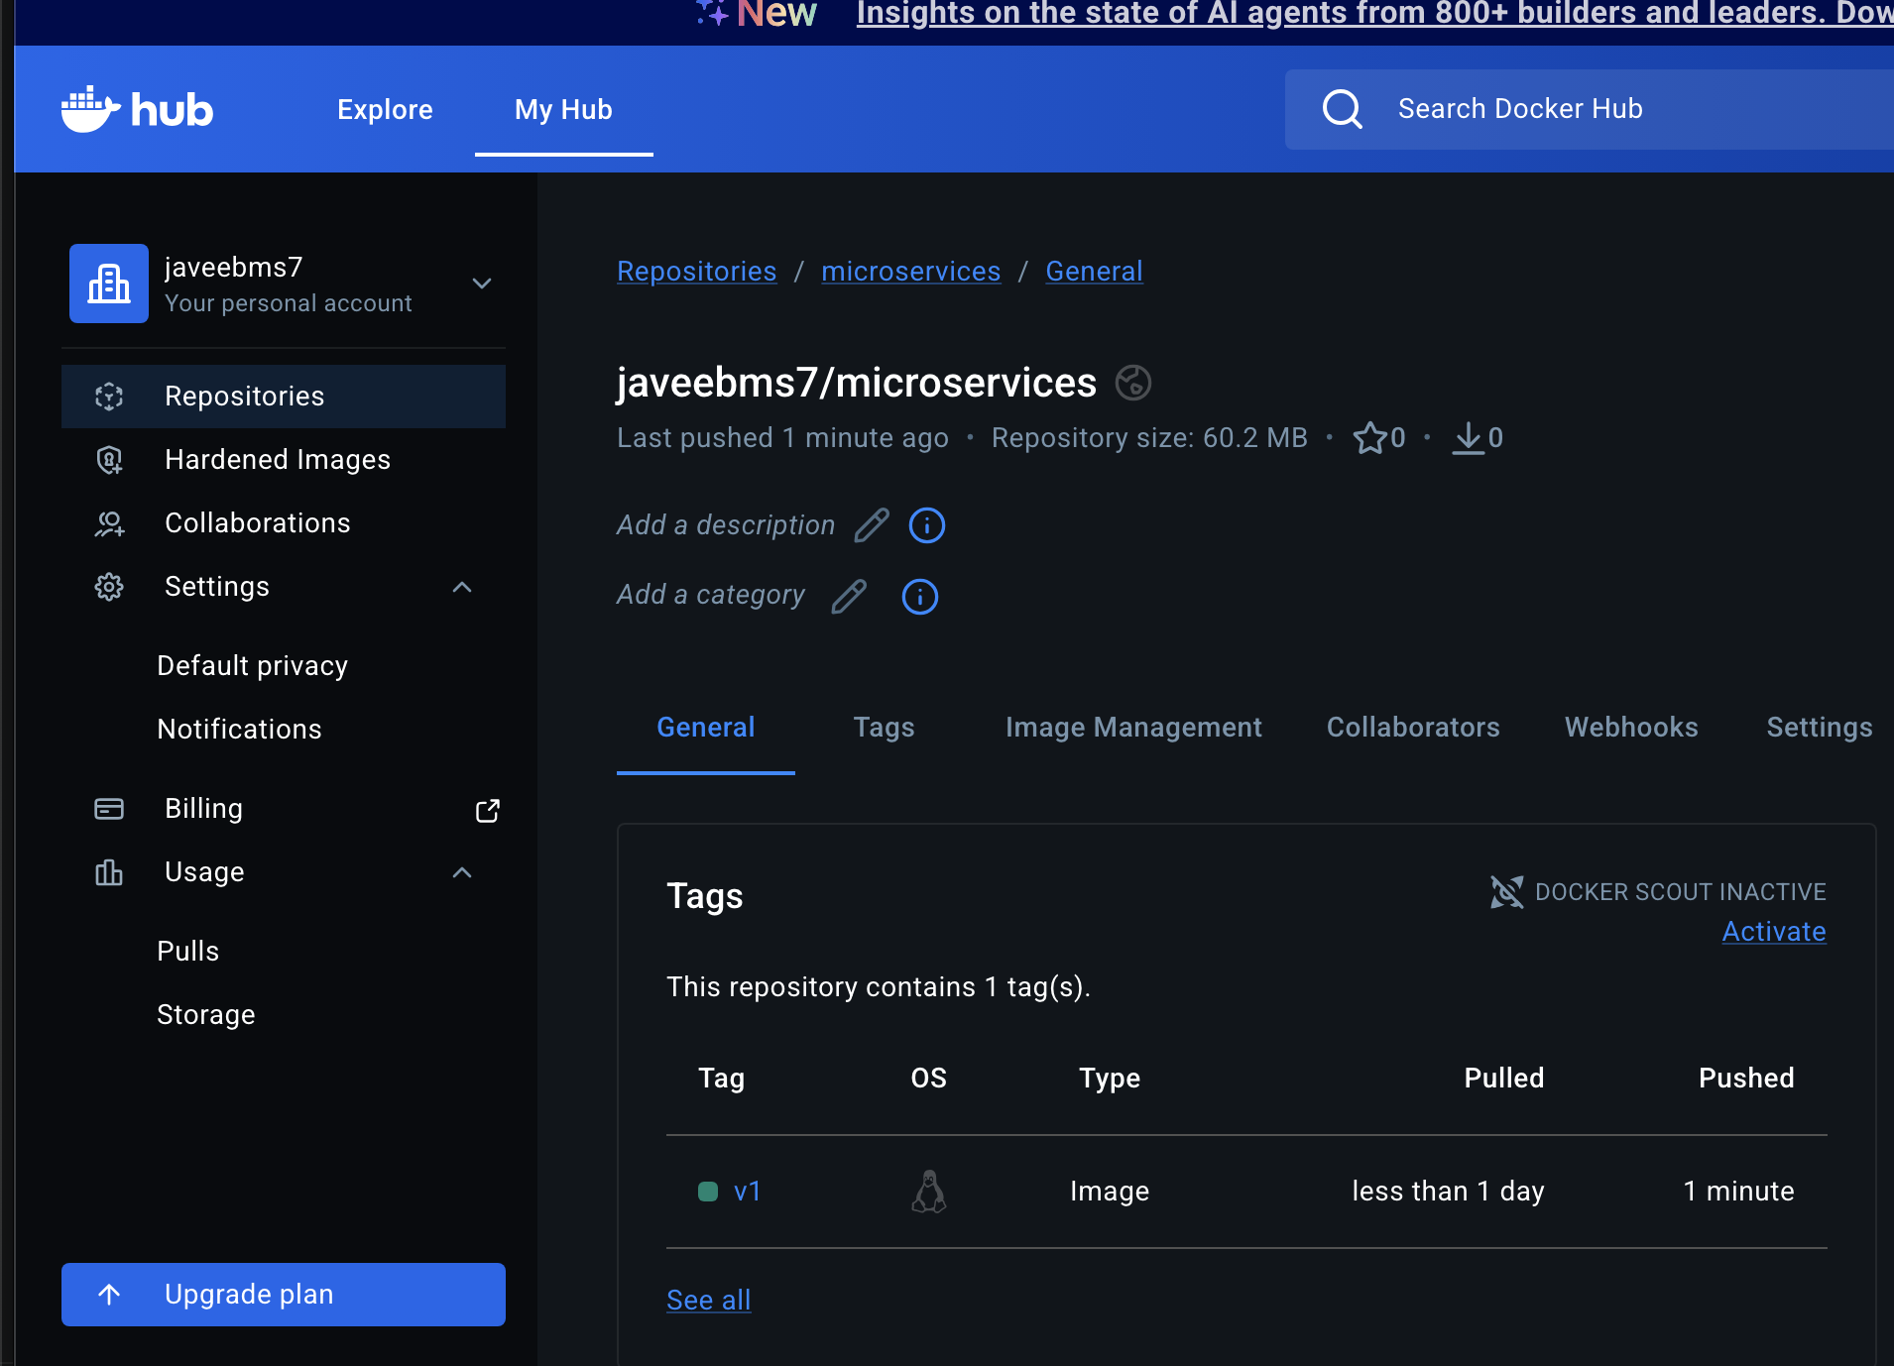

📌 Note: Docker Hub is used as the container registry. The image javeebms7/microservices:v1 is publicly accessible so the EC2 instance can pull it without authentication.

4. Terraform Code — main.tf (Detailed Walkthrough)
main.tf is the heart of the infrastructure code. It is divided into logical sections using comments. Each section is explained below.

4.1 Provider Block
provider "aws" {
region = "us-east-1"
}

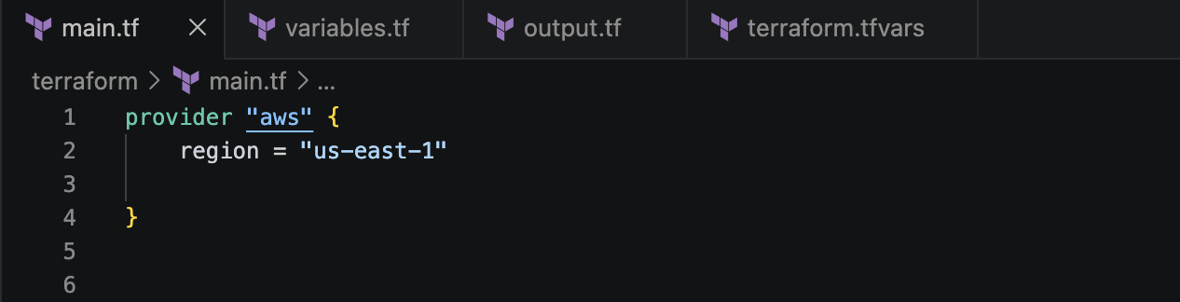
The provider block tells Terraform which cloud platform to use (AWS) and in which region to create the resources. us-east-1 is AWS's Northern Virginia region — one of the most commonly used regions with the widest service availability.

4.2 Availability Zones Data Source
data "aws_availability_zones" "available" {}
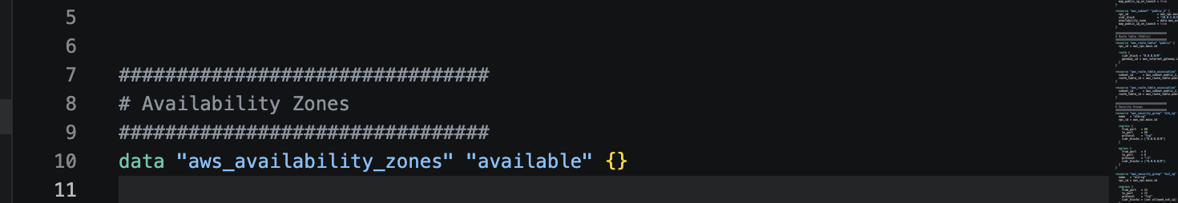
This is a data source — it reads existing information from AWS rather than creating something new. It fetches the list of available Availability Zones (AZs) in us-east-1. An Availability Zone is a physically separate data center within a region. By dynamically reading AZs, the code avoids hardcoding zone names (e.g., us-east-1a, us-east-1b), making it more portable.

4.3 VPC (Virtual Private Cloud)
resource "aws_vpc" "main" {
cidr_block = "10.0.0.0/16"
enable_dns_support = true
enable_dns_hostnames = true
}

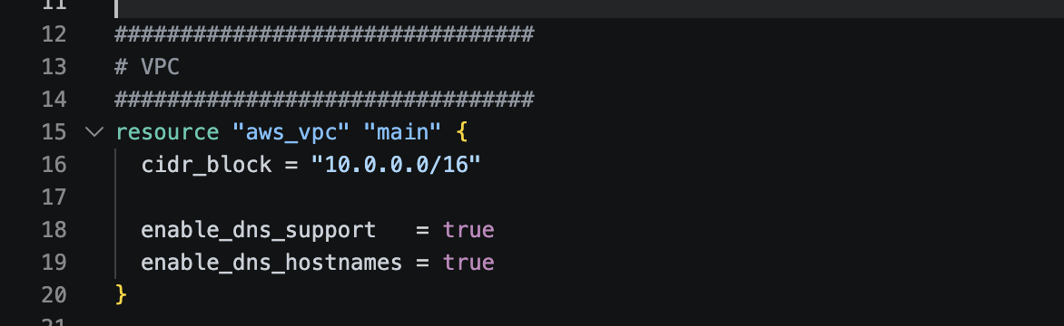
A VPC is a private, isolated network on AWS — like having your own private section of the internet inside AWS's infrastructure. Everything (EC2, ALB, subnets) lives inside this VPC.

Setting | Value | Meaning
cidr_block | 10.0.0.0/16 | The IP address range for the entire VPC. /16 gives 65,536 possible IP addresses.
enable_dns_support | true | Allows AWS to resolve DNS names within the VPC.
enable_dns_hostnames | true | Allows EC2 instances to get DNS hostnames. Needed for some services to resolve correctly.

4.4 Internet Gateway
resource "aws_internet_gateway" "igw" {
vpc_id = aws_vpc.main.id
}
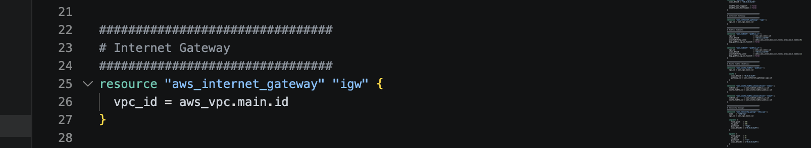
An Internet Gateway (IGW) is the bridge between the VPC and the public internet. Without it, no resource in the VPC can communicate with the outside world. It is attached to the VPC by referencing aws_vpc.main.id.

4.5 Public Subnets
resource "aws_subnet" "public_1" {
vpc_id = aws_vpc.main.id
cidr_block = "10.0.1.0/24"
availability_zone = data.aws_availability_zones.available.names[0]
map_public_ip_on_launch = true
}

resource "aws_subnet" "public_2" {
vpc_id = aws_vpc.main.id
cidr_block = "10.0.2.0/24"
availability_zone = data.aws_availability_zones.available.names[1]
map_public_ip_on_launch = true
}
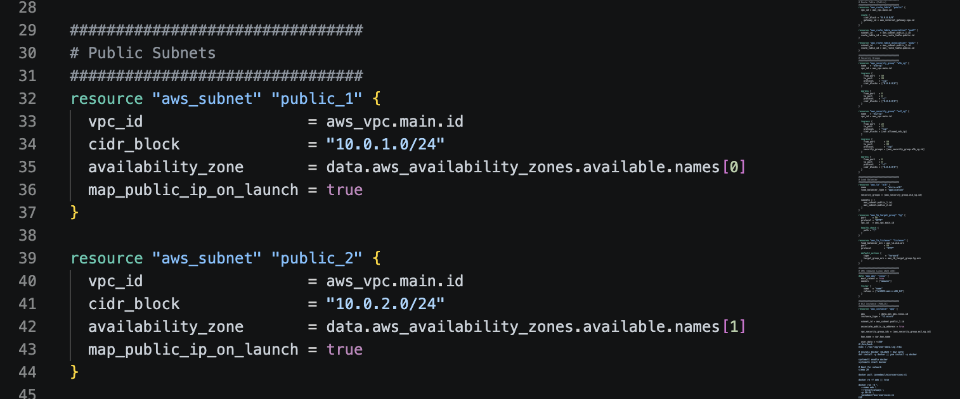
Two public subnets are created in different Availability Zones. This is required by the Application Load Balancer — it must span at least two AZs for high availability. Each subnet gets a /24 range (256 IP addresses). The map_public_ip_on_launch = true setting ensures that any EC2 instance launched in these subnets automatically gets a public IP address.

📌 Note: Subnets are subdivisions of the VPC. public_1 lives in AZ[0] (e.g., us-east-1a) and public_2 lives in AZ[1] (e.g., us-east-1b).

4.6 Route Table
resource "aws_route_table" "public" {
vpc_id = aws_vpc.main.id
route {
cidr_block = "0.0.0.0/0"
gateway_id = aws_internet_gateway.igw.id
}
}

resource "aws_route_table_association" "pub1" {
subnet_id = aws_subnet.public_1.id
route_table_id = aws_route_table.public.id
}

resource "aws_route_table_association" "pub2" {
subnet_id = aws_subnet.public_2.id
route_table_id = aws_route_table.public.id
}
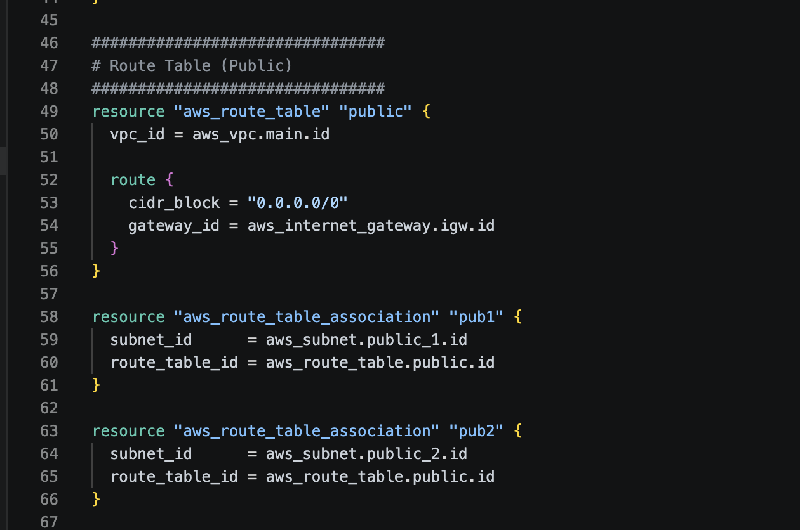
A route table is like a GPS map for network traffic — it tells packets where to go. The rule 0.0.0.0/0 means 'for any destination on the internet, send traffic through the Internet Gateway.' The two association resources attach this route table to both public subnets, making them truly public.

4.7 Security Groups
Security Groups act as virtual firewalls. There are two security groups in this project:

Security Group 1: ALB Security Group (alb_sg)
resource "aws_security_group" "alb_sg" {
name = "alb-sg"
vpc_id = aws_vpc.main.id

ingress {
from_port = 80
to_port = 80
protocol = "tcp"
cidr_blocks = ["0.0.0.0/0"]
}

egress {
from_port = 0
to_port = 0
protocol = "-1"
cidr_blocks = ["0.0.0.0/0"]
}
}
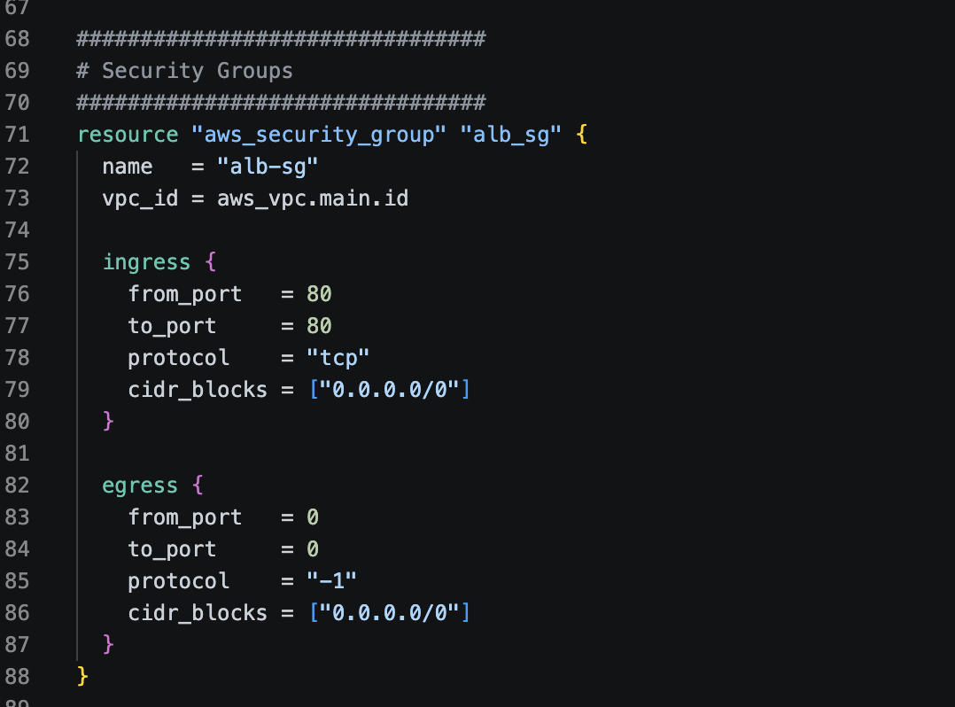
Rule | Direction | Port | Source | Purpose
ingress | Inbound | 80 (HTTP) | 0.0.0.0/0 (anywhere) | Allow users from the internet to reach the ALB on port 80
egress | Outbound | All ports | 0.0.0.0/0 (anywhere) | Allow ALB to send traffic to the EC2 instance

Security Group 2: EC2 Security Group (ec2_sg)
resource "aws_security_group" "ec2_sg" {
name = "ec2-sg"
vpc_id = aws_vpc.main.id

ingress {
from_port = 22
to_port = 22
protocol = "tcp"
cidr_blocks = [var.allowed_ssh_ip]
}

ingress {
from_port = 80
to_port = 80
protocol = "tcp"
security_groups = [aws_security_group.alb_sg.id]
}

egress { ... }
}
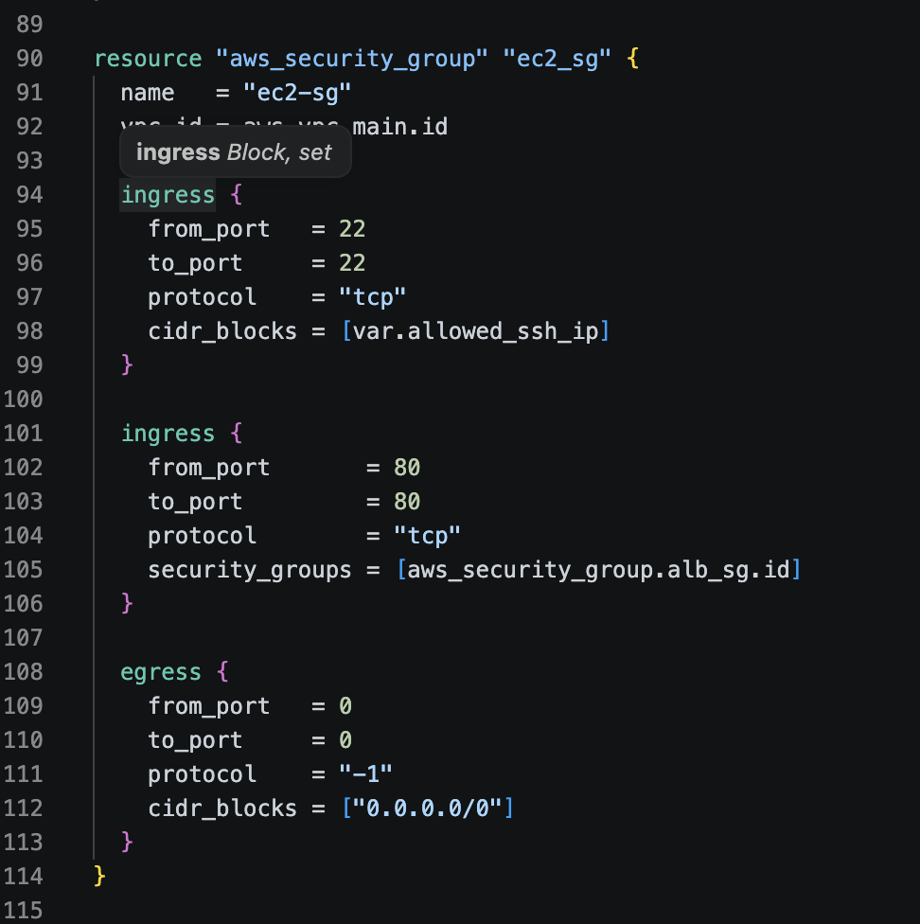
Rule | Direction | Port | Source | Purpose
ingress #1 | Inbound | 22 (SSH) | var.allowed_ssh_ip only | Only your specific IP can SSH into the EC2 instance
ingress #2 | Inbound | 80 (HTTP) | ALB Security Group only | Only traffic from the ALB reaches port 80 on EC2
egress | Outbound | All | Anywhere | EC2 can reach Docker Hub, package repos, etc.

📌 Note: The key security design: port 80 on the EC2 is NOT open to 0.0.0.0/0. It only accepts traffic that originated from the ALB. This is the 'not accessible from internet, only through ALB' requirement being enforced.

4.8 Application Load Balancer (ALB)
resource "aws_lb" "alb" {
name = "micro-alb"
load_balancer_type = "application"
security_groups = [aws_security_group.alb_sg.id]
subnets = [
aws_subnet.public_1.id,
aws_subnet.public_2.id
]
}

resource "aws_lb_target_group" "tg" {
port = 80
protocol = "HTTP"
vpc_id = aws_vpc.main.id
health_check { path = "/" }
}

resource "aws_lb_listener" "listener" {
load_balancer_arn = aws_lb.alb.arn
port = 80
protocol = "HTTP"
default_action {
type = "forward"
target_group_arn = aws_lb_target_group.tg.arn
}
}

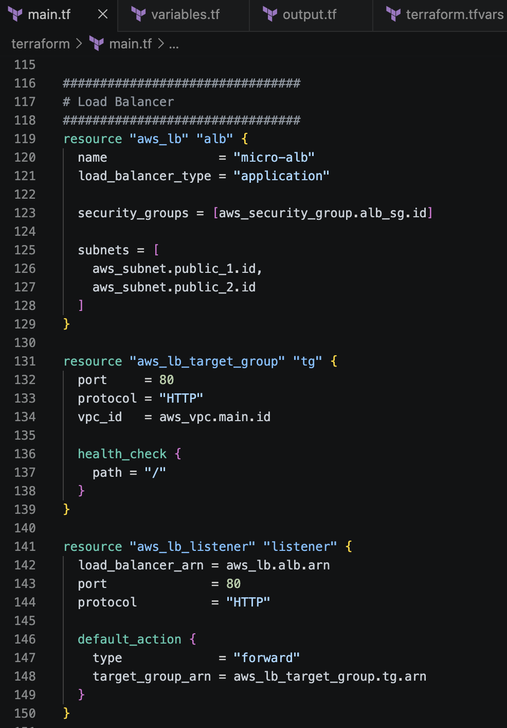
The ALB setup has three parts working together:

Resource | Role | Analogy
aws_lb | The load balancer itself | The reception desk at a hotel — all visitors come here first
aws_lb_target_group | The group of EC2 instances to send traffic to | The list of rooms available for guests
aws_lb_listener | The rule: on port 80, forward to the target group | The receptionist's instruction: send all guests to the available rooms

The health_check path = '/' means the ALB periodically sends a GET request to the EC2 instance's root URL. If it gets a 200 OK response, the instance is healthy. If not, the ALB stops sending traffic to it.

4.9 AMI Data Source
data "aws_ami" "linux" {
most_recent = true
owners = ["amazon"]
filter {
name = "name"
values = ["al2023-ami-*-x86_64"]
}
}
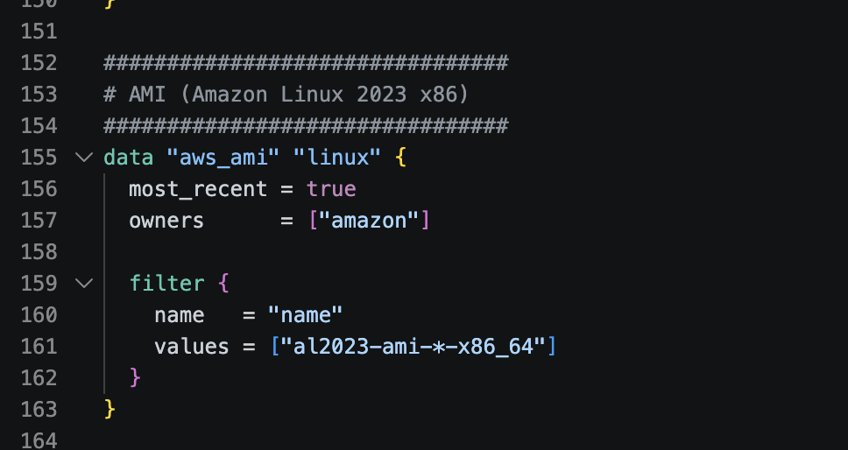
An AMI (Amazon Machine Image) is like a pre-installed operating system snapshot used to create EC2 instances. Instead of hardcoding a specific AMI ID (which changes per region and becomes outdated), this data source dynamically looks up the latest Amazon Linux 2023 64-bit AMI. The filter pattern al2023-ami-*-x86_64 matches official Amazon Linux 2023 images.

4.10 EC2 Instance with User Data
resource "aws_instance" "app" {
ami = data.aws_ami.linux.id
instance_type = "t3.micro"
subnet_id = aws_subnet.public_1.id
associate_public_ip_address = true
vpc_security_group_ids = [aws_security_group.ec2_sg.id]
key_name = var.key_name

user_data = <<EOF
#!/bin/bash
exec > /var/log/user-data.log 2>&1

# Install Docker (AL2023 + AL2 safe)
dnf install -y docker || yum install -y docker

systemctl enable docker
systemctl start docker

# Wait for network
sleep 20

docker pull javeebms7/microservices:v1

docker rm -f web || true

docker run -d \
--name web \
--restart=always \
-p 80:80 \
javeebms7/microservices:v1
EOF
}
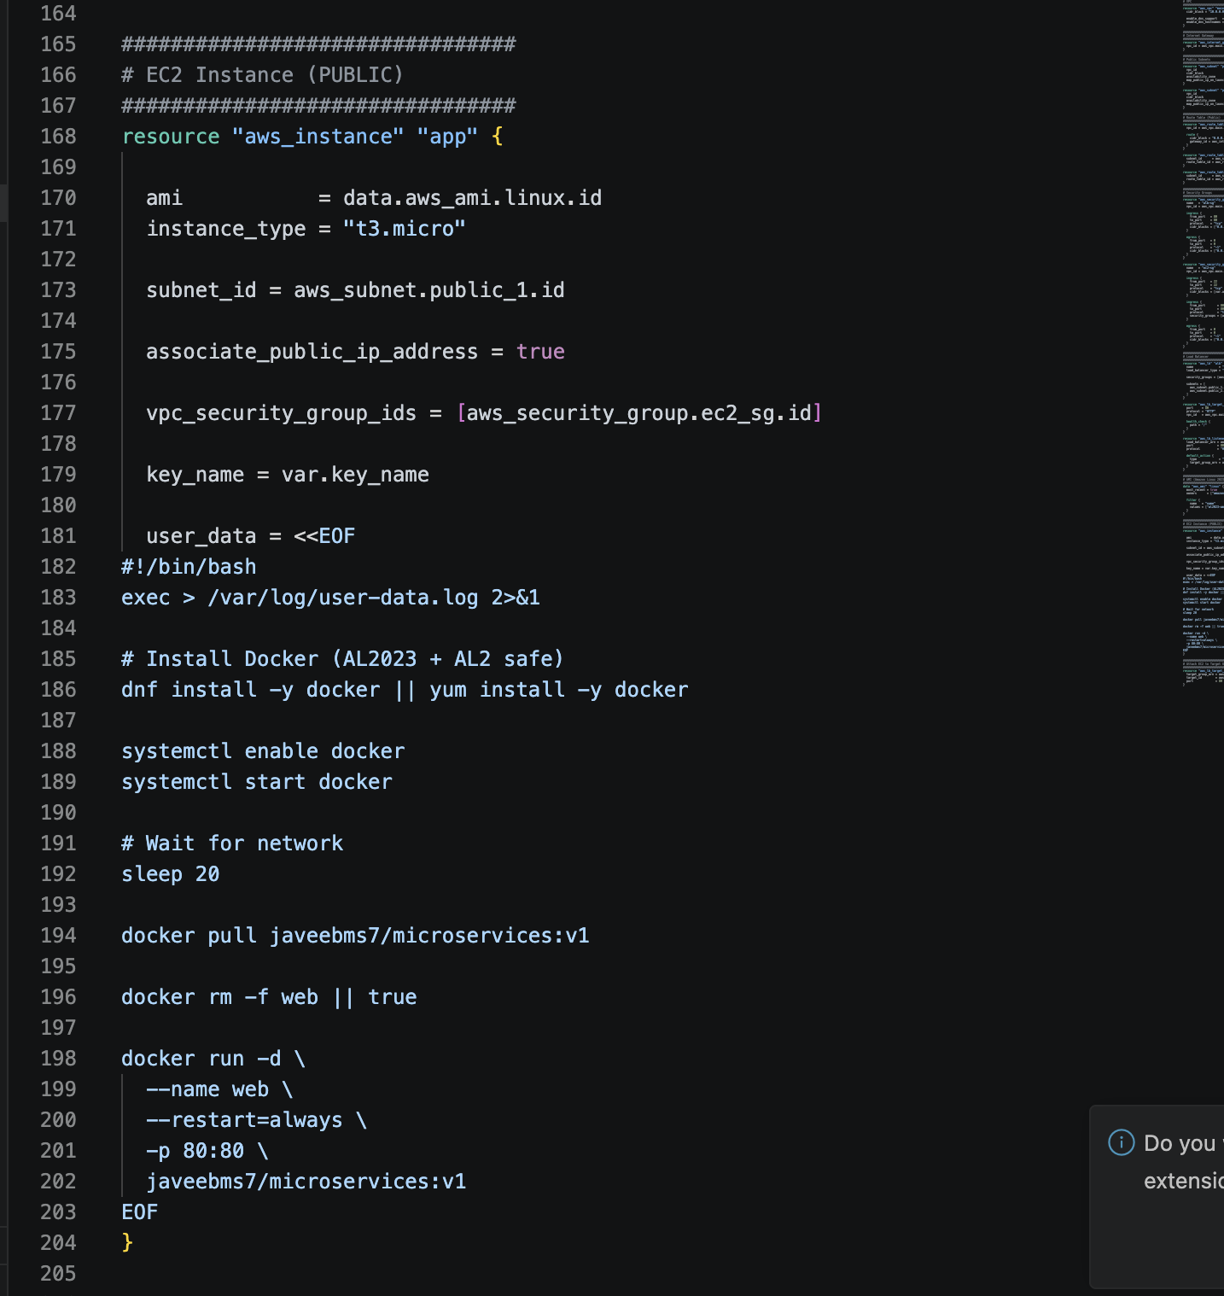

EC2 Instance Settings
Parameter | Value | Explanation
ami | data.aws_ami.linux.id | Uses the dynamically fetched Amazon Linux 2023 AMI ID
instance_type | t3.micro | Free-tier eligible VM with 2 vCPUs and 1 GB RAM
subnet_id | public_1 | Places the EC2 in the first public subnet
associate_public_ip_address | true | Gives the EC2 a public IP so it can reach the internet (to pull Docker image)
vpc_security_group_ids | ec2_sg | Attaches the EC2 security group with the port rules defined earlier
key_name | var.key_name | Attaches an SSH key pair for secure access. Value comes from terraform.tfvars

User Data Script — Line by Line
user_data is a bootstrap script that runs automatically when the EC2 instance starts for the first time. It is the equivalent of a setup script that configures the server.

Command | Purpose
exec > /var/log/user-data.log 2>&1 | Redirects all script output to a log file. Critical for debugging — if something goes wrong, you can SSH in and read this file.
dnf install -y docker || yum install -y docker | Installs Docker. Uses dnf (AL2023 package manager) first, falls back to yum (AL2 package manager) if that fails. The || means 'try the second command if the first fails'.
systemctl enable docker | Configures Docker to start automatically whenever the server reboots.
systemctl start docker | Starts Docker immediately right now.
sleep 20 | Waits 20 seconds for network connectivity to stabilize before pulling from Docker Hub.
docker pull javeebms7/microservices:v1 | Downloads the container image from Docker Hub to the EC2 instance.
docker rm -f web || true | Removes any previously running container named 'web'. The || true prevents the script from failing if no such container exists.
docker run -d --name web --restart=always -p 80:80 javeebms7/microservices:v1 | Starts the container: -d runs it in background, --restart=always restarts it if it crashes, -p 80:80 maps EC2 port 80 to container port 80.

4.11 Target Group Attachment
resource "aws_lb_target_group_attachment" "attach" {
target_group_arn = aws_lb_target_group.tg.arn
target_id = aws_instance.app.id
port = 80
}

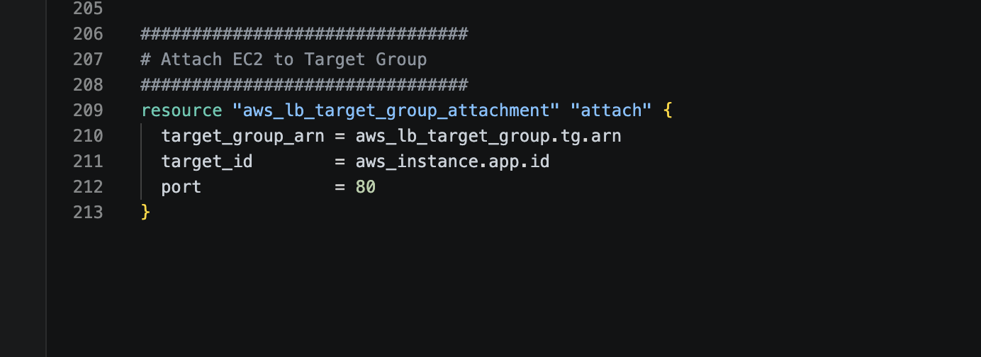
This resource registers the EC2 instance with the ALB Target Group. Without this, the ALB would have no EC2 instances to forward traffic to — the load balancer would have nothing to balance. It connects the EC2 instance (target_id) to the target group on port 80.

5. Variables, Outputs & tfvars

5.1 variables.tf
variable "allowed_ssh_ip" {
type = string
}

variable "key_name" {
type = string
}
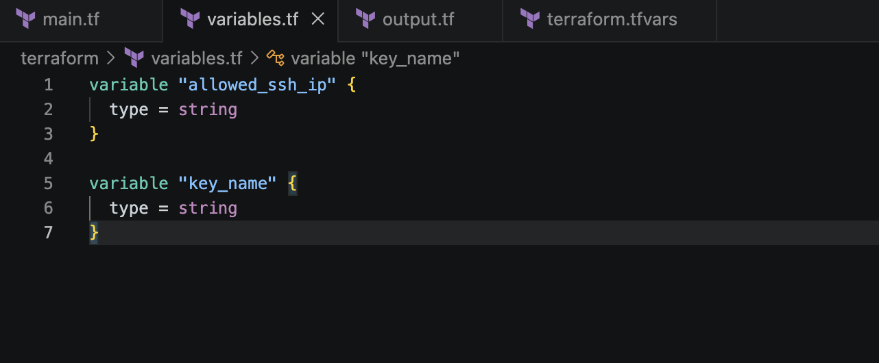
Variables make the Terraform code reusable. Instead of hardcoding sensitive or environment-specific values directly in main.tf, they are declared as variables here and given actual values in terraform.tfvars.

Variable | Type | Used In | Purpose
allowed_ssh_ip | string | ec2_sg ingress rule | The IP address allowed to SSH into the EC2 instance. Only this IP can connect on port 22.
key_name | string | aws_instance resource | The name of the SSH key pair stored in AWS. Must be created in AWS before running Terraform.

5.2 terraform.tfvars
allowed_ssh_ip = "103.24.20.203/32"
key_name = "jenkins"
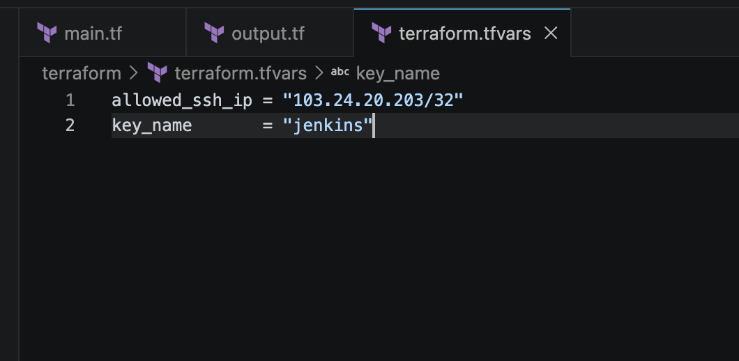
This file provides the actual values for the variables declared in variables.tf. Terraform automatically reads this file when running terraform apply.

Value | Explanation
"103.24.20.203/32" | Your public IP address in CIDR notation. The /32 means exactly this one IP — no range. Only connections from this IP are allowed on port 22.
"jenkins" | The name of the EC2 Key Pair in AWS. This key pair was created beforehand in the AWS Console and saved locally as jenkins.pem.

📌 Note: Never commit terraform.tfvars to a public Git repository if it contains sensitive values like IPs, passwords, or access keys.

5.3 outputs.tf
output "alb_dns" {
value = aws_lb.alb.dns_name
}

output "ec2_public_ip" {
value = aws_instance.app.public_ip
description = "Public IP of the EC2 instance (for SSH only)"
}
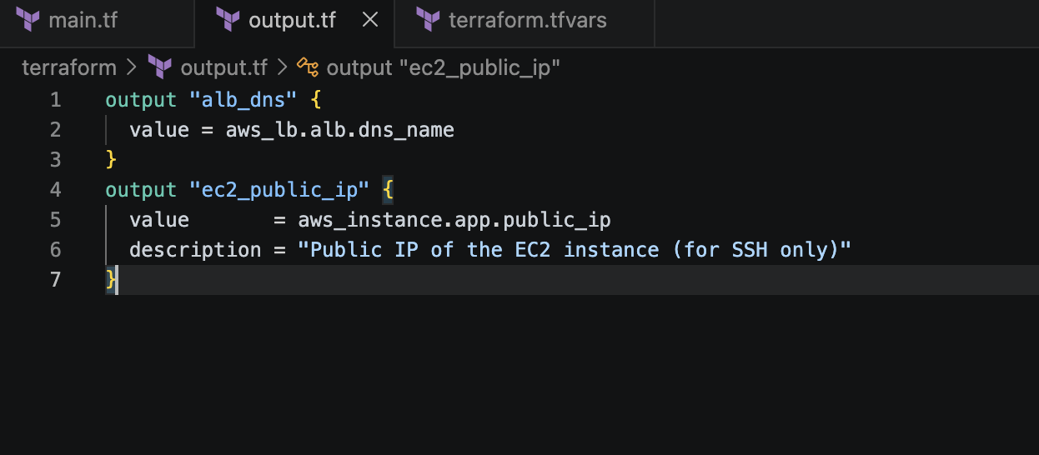
Outputs display important values after terraform apply completes. Instead of logging into AWS Console to find the ALB URL or EC2 IP, these values are printed directly in the terminal.

Output | What It Shows | How It's Used
alb_dns | The ALB's public DNS name (e.g., micro-alb-123456.us-east-1.elb.amazonaws.com) | Open this URL in a browser to see the deployed web page
ec2_public_ip | The EC2 instance's public IP address | Use this IP to SSH: ssh -i jenkins.pem ec2-user@<this-ip>

6.

Step 3: Initialize Terraform
terraform init

terraform init downloads the required AWS provider plugin and sets up the working directory. This must be run once before any other Terraform commands.

Step 4: Review the Plan
terraform plan

terraform plan shows exactly what Terraform will create, modify, or destroy — without actually doing it. It is a dry run. Always review the plan before applying.

Step 5: Deploy the Infrastructure
terraform apply

terraform apply creates all the AWS resources. It will ask for confirmation (type 'yes'). This step creates the VPC, subnets, security groups, ALB, EC2 instance, and connects everything together.
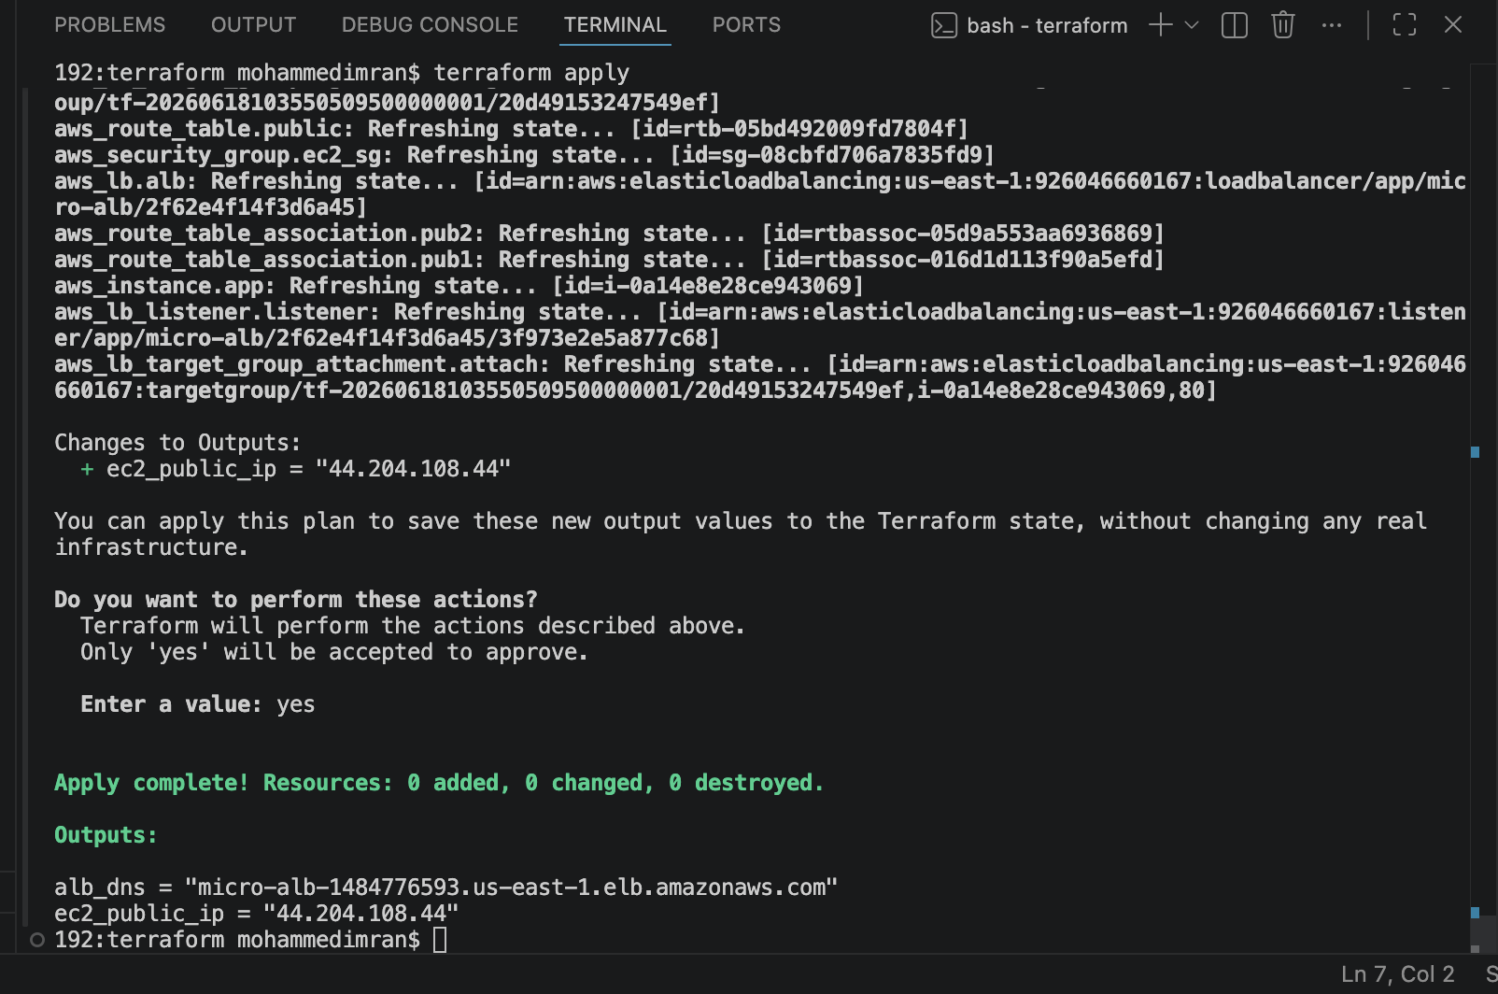

After completion, the outputs section will display:
- alb_dns — the URL to test the deployed application
- ec2_public_ip — the IP to SSH into the instance

Step 6: Verify the Deployment
# Open in browser:
http://<alb_dns_output>

# Expected result: The static HTML page loads
# 'Hello from Docker Container!'
# 'Deployed using Terraform on AWS EC2.'

# SSH into the EC2 instance (optional verification):
ssh -i jenkins.pem ec2-user@<ec2_public_ip>

# Check if Docker container is running:
docker ps
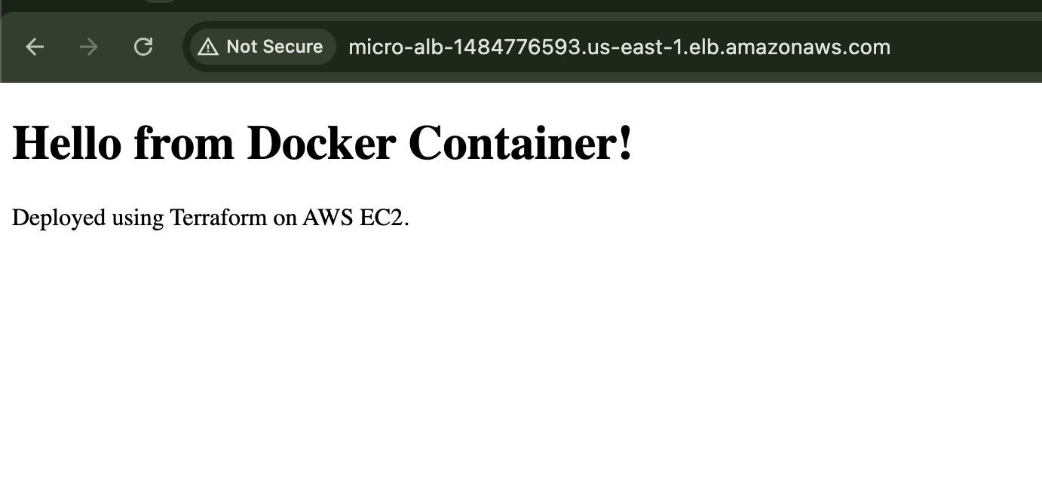

Ipaddress:80 ⇒ its not exposed to public
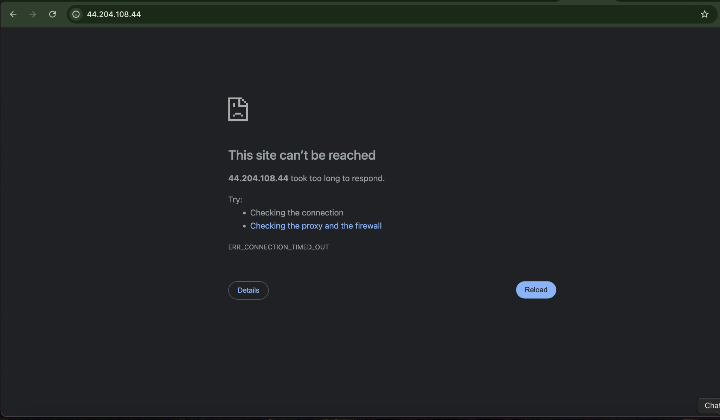

Step 7: Destroy the Infrastructure (Clean Up)
terraform destroy

terraform destroy removes all created resources from AWS. This is important when using a free-tier account — leaving resources running (especially ALBs and EC2) can incur charges.

